**Setup**

1. Open the project and click on the .sln fileA screenshot of a computer screen

   Description automatically generated
2. Download MS SQL Server Management Studio (SSMS)
3. Connect to your local serverA screenshot of a computer

   Description automatically generated
4. Create a new database called “QuizAssessmentDB” A screenshot of a computer

   Description automatically generated
5. Delete the Migration folder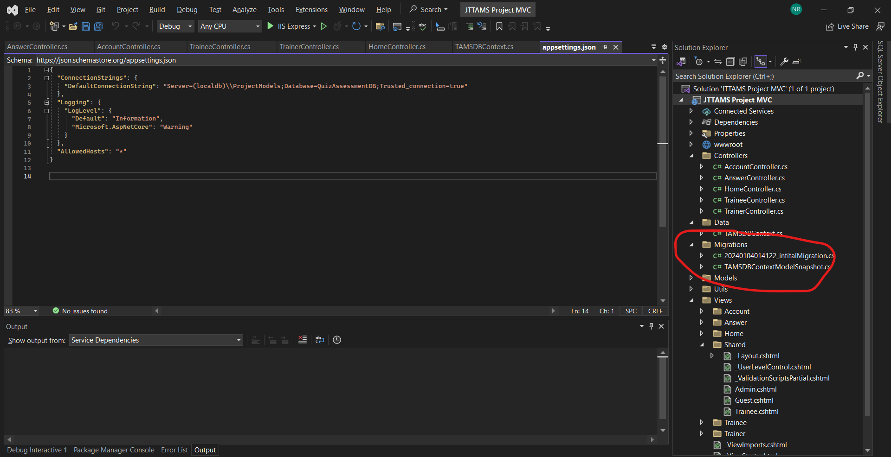
6. Go search and type “Package Manager Console” A screenshot of a computer

   Description automatically generated
7. Write “Add-Migration InitialCreate”, wait till the build is successful and then “Update-Database”
8. Then run the app through IIS express

Steps to create an Admin Account

1. Register an account first A screenshot of a computer

   Description automatically generated
2. Open SSMS, right click on “dbo.Users”, and select “Edit top 200 rows” A computer screen with a blue background

   Description automatically generated
3. Edit the column from “trainee” to “admin” A screenshot of a computer

   Description automatically generated